The technique can be best understood with the window pane in bus, consider a window of length **n** and the pane which is fixed in it of length **k**. Consider, initially the pane is at extreme left i.e., at 0 units from the left. Now, co-relate the window with array arr[] of size n and pane with current_sum of size k elements. Now, if we apply force on the window such that it moves a unit distance ahead. The pane will cover next **k** consecutive elements.

Consider an array **arr[]** = {5, 2, -1, 0, 3} and value of **k** = 3 and **n** = 5

**Applying sliding window technique**:

1. We compute the sum of first k elements out of n terms using a linear loop and store the sum in variable window_sum.
2. Then we will graze linearly over the array till it reaches the end and simultaneously keep track of maximum sum.
3. To get the current sum of block of k elements just subtract the first element from the previous block and add the last element of the current block .

The below representation will make it clear how the window slides over the array.

This is the initial phase where we have calculated the initial window sum starting from index 0 . At this stage the window sum is 6. Now, we set the maximum_sum as current_window i.e 6.  
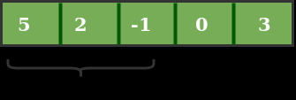

Now, we slide our window by a unit index. Therefore, now it discards 5 from the window and adds 0 to the window. Hence, we will get our new window sum by subtracting 5 and then adding 0 to it. So, our window sum now becomes 1. Now, we will compare this window sum with the maximum_sum. As it is smaller we wont the change the maximum_sum.

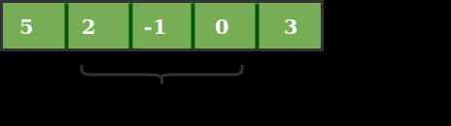

Similarly, now once again we slide our window by a unit index and obtain the new window sum to be 2. Again we check if this current window sum is greater than the maximum_sum till now. Once, again it is smaller so we don’t change the maximum_sum.

Therefore, for the above array our maximum_sum is 6.

